

Can Diversified Investment Portfolios Hedge Against Inflation and Market Volatility?

"Do Diversified Portfolios Effectively Hedge Inflation and Volatility Risks?”

Luís Peixoto

Dissertation written under the supervision of Professor Eva Schliephake

Dissertation submitted in partial fulfilment of requirements for the MSc in Finance, at the Universidade Católica Portuguesa, June 2nd 2025.

Can Diversified Investment Portfolios Hedge Against Inflation and Market Volatility?

Luís Peixoto

Abstract

Can Diversified Investment Portfolios Hedge Against Inflation and Market Volatility?

Luís Peixoto

Resumo

Table of Contents

1. **Introduction**

Inflation and Market Volatility are at the core of every investment manager’s decision-making process, capital allocation and in every retail investor’s concerns. Inflation will diminish the purchasing-power of your income and the real value of your portfolio’s returns, while market volatility will introduce uncertainty and a degree of risk that may not be adjusted to your risk aversion. Innovations in any of these macroeconomic variables are in the top tier of the concern scale of money managers and retail investors. Protection against these variables is often measured and named in the form of a hedge. Following Bodie (1976), an effective hedge, against both inflation and market volatility, is defined to the extent that they can be used to diminish or eliminate the risk of the portfolio’s real return in what concerns the future levels of the consumer price index (CPI) and the future levels of market uncertainty. Over the past century, the world has experienced periods of high inflation, such as the German hyperinflation post-World War I, the “Great Inflation” of the 1970s and the post-COVID inflation surge. The periods on which high volatility was observed have not been less significative than those we have seen, most of these periods are and will be remembered for decades to come, namely, the Great Depression of 1929, the Black Monday on October 1987, the Dot-com crash, the Global Financial Crisis and the latest, the COVID-19 crash. However, there are multiple periods on which both phenomena were observed. The most remarkable have been the 1970s Stagflation and the post-COVID period. It is with the latest period of the aforementioned events still in mind, and with the latest market turmoil caused by the reciprocal tariffs that the relevance of the topic addressed in this thesis becomes increasingly relevant. Many studies have been conducted regarding the effectiveness of certain asset classes in hedging inflation, but this paper aims to include different asset classes, including alternative assets, with different geographies. Concerning the study of market volatility hedges, most of past studies conducted use complex and structured derivative products focusing on short-term hedging.

This paper focuses on addressing a topic that has not been addressed in past literature, creating a strategic asset allocation by buying and holding the same assets for the same investment horizon, fixing weights for the whole holding period and trying to hedge against inflation and market volatility risk, while building on geographical diversification. By trying to hedge both of these risks, the paper contributes to the vast literature on inflation hedging and the not so sizable literature on market risk hedging without complex financial products. However, an immediate answer can be raised by the reader, the one that aims to question the **orthogonality of inflation and volatility and the sense it may do to study the hypotheses proposed in this paper**

**What the paper finds**.

**Extensions/heterogeneity analyses/mechanisms (“extensions+”)**

**Paragraphs X+1/X+2: Literature contributions.**

**Structure of the Paper**

1. **Data**

**2.1 Data Description**

The data used in this paper is fetched from different sources and databases. The period that serves as input is the start of 1980 until the last trading day of December 2024, and data is . Wi Inflation rates are estimated using the log difference of monthly values, either in a one-month interval or a twelve-month interval, in the series US Consumer Price Index for All Urban Consumers from FRED. Inflation rate in the whole paper will be addressed at on a Year-over-Year basis mainly and its evolution throughout the studied period from 1980 until 2024 can be seen on graph Y.

Volatility data is calculated from the monthly returns on MSCI World Index, with data from Refinitiv Eikon/LSEG Workspace, the returns for this series are calculated as the log differential from the monthly closing prices of the index. From the previously mentioned data, two volatility estimates were calculated, an Historical Volatility Variable, computed from a rolling twelve-month standard deviation of the index continuously compounded monthly returns, and a GARCH Volatility variable, using a GARCH (1,1) model, meaning, an order one autoregressive term and an order one moving average term. The GARCH (1,1) model is used to capture and forecast the volatility of the MSCI World Index returns, representing the model's estimate of the volatility at each month, this variable will be mainly used for robustness. On graph X, the reader can observe the small amplitude between both measurements of volatility.

To build the diversified investment portfolios several assets were selected. This selection was done to have as much diversification as possible, on the one hand to have as much exposure to different asset classes as possible, on the other hand, this diversification also happens geographically. For all assets, continuously compounded returns were calculated, allowing an easier computation of cumulative returns, through its additive properties, whilst its statistical properties allow greater symmetry and its approximation to normal distribution, catalysing a increasingly reliable regression analysis and hypothesis testing. The equity indexes chosen are the S&P 500 Index, the Russell 2000 Index, the tech heavy NASDAQ Composite Index, the FTSE 100 Index, the DAX 40 Index, the Euro Stoxx 50 Index, and the Nikkei 225 Index. These indices’ data was obtained mainly from LSEG Workspace, whilst the S&P 500 data was extracted from CRSP and the Nikkei 225 data was retrieved from Compustat in WRDS. For Real Estate Investment Trusts (REITs), the selection was the FTSE Nareit U.S. Real Estate Index Series, from National Association of Real Estate Investment Trusts database.

Gold, commonly regarded by the average investor as the obvious hedge against inflation risk, is one of the key assets in this paper, its spot price in US Dollars is also extracted from LSEG Workspace. For Oil, the most traded commodity worldwide, this paper will study the NYMEX Light Sweet Crude Oil (WTI) Electronic Energy Future Continuation 1 (CLc1). On Foreign Exchange pair territory, the EUR/USD, JPY/USD, CHF/USD spot rates were selected for the portfolios construction. The reader may argue that the EURO was only launched in 1999, that’s why Refinitiv uses a synthetic rate, following the European Central Bank’s approach, of a weighted average of the currencies of the eleven countries that originally constituted the Eurozone.

Due to limited access to Treasury Inflation-Protected Securities data, as a proxy, for the total return index, the chosen asset was the iShares TIPS Bond ETF which tracks the results of an index composed by Treasury Inflation-Protected Securities bonds with different maturities. Finally, for the 10-Year Treasury Bond, we selected the data from CRSP on the Total Return Index.

* 1. **Summary Statistics**

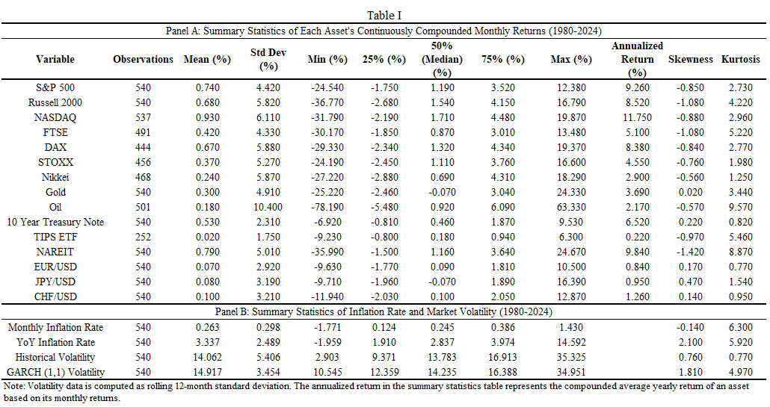

Table I presents the summary statistics for all the assets selected for portfolio construction and for the two macroeconomic variables this paper studies. The study is conducted on 540 months of data and most assets have observable data on all these months, in fact, 15 of the 16 assets have data on more than 82% of the period’s months.

From this Table, the reader can infer that the best performing assets, in this universe, in the period from 1980 through 2024, based on the Annualized Return Data, were the Equity Indexes from the United States and Germany and the NAREIT Index. Whilst the ones that exhibited the lowest level of returns were the currencies and the iShares TIPS Bond ETF. In what concerns volatility of these assets, one can immediately observe that the instruments with lowest performance throughout this period are also the ones with the lowest volatility.

**10. References**

Bodie, Zvi. "Common stocks as a hedge against inflation." *The journal of finance* 31.2 (1976): 459-470.